CNN Architectures

11. CNN Architectures
Convolutional Neural Networks have been around since the early 1990s.
- LeNet (the 1990s)
- AlexNet (2012)
- ZF Net (2013)
- GoogLeNet (2014)
- VGGNet (2014)
- ResNets (2015)
- DenseNet (August 2016)

LeNet 5 Architecture:
LeNet 5 architecture is the ‘Hello World’ in the domain of Convolution Neural Networks. The backpropagation rule was first applied to all reasonable applications in 1989 by Yann LeCun and colleagues at Bell Labs. They also argued that by imposing limitations from the tasks domain, network generalization’s flexibility could be significantly strengthened. LeCun established that single-layer networks do tend to exhibit weak generalisation skills by explaining a modest handwritten digit identification anomaly in another publication within the same year, even supposing the problem is linearly separable. A multi-layered, unnatural network may function exceptionally well once an anomaly is eliminated using invariant feature detectors. He thought that these findings proved that reducing the number of free parameters in the neural network could improve its ability to generalise.
What is LeNet 5?
LeNet is a convolutional neural network that Yann LeCun introduced in 1989. LeNet is a common term for LeNet-5, a simple convolutional neural network.
The LeNet-5 signifies CNN’s emergence and outlines its core components. However, it was not popular at the time due to a lack of hardware, especially GPU (Graphics Process Unit, a specialised electronic circuit designed to change memory to accelerate the creation of images during a buffer intended for output to a show device) and alternative algorithms, like SVM, which could perform effects similar to or even better than those of the LeNet.
Features of LeNet-5
- Every convolutional layer includes three parts: convolution, pooling, and nonlinear activation functions
- Using convolution to extract spatial features (Convolution was called receptive fields originally)
- The average pooling layer is used for subsampling.
- ‘tanh’ is used as the activation function
- Using Multi-Layered Perceptron or Fully Connected Layers as the last classifier
- The sparse connection between layers reduces the complexity of computation
Architecture
The LeNet-5 CNN architecture has seven layers. Three convolutional layers, two subsampling layers, and two fully linked layers make up the layer composition.
Press enter or click to view image in full size
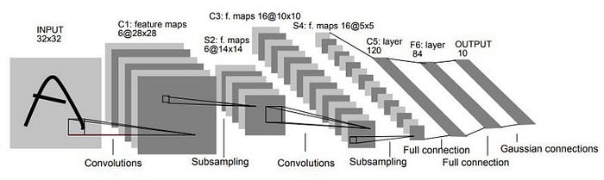
LeNet-5 Architecture

- Input Layer: Accepts a grayscale image of size 32×32.
- C1 — Convolutional Layer: Uses 6 filters of size 5×5 with a stride of 1, producing a feature map of size 28×28.
- S2 — Subsampling (Pooling) Layer: Applies average pooling with a kernel size of 2×2 and a stride of 2, reducing the feature map to 14×14.
- C3 — Convolutional Layer: Uses 16 filters of size 5×5 with a stride of 1, giving output feature maps of size 10×10.
- S4 — Subsampling (Pooling) Layer: Again applies average pooling, resulting in feature maps of size 5×5.
- C5 — Fully Connected Convolutional Layer: This layer has 120 neurons, each connected to all 5x5 feature maps from the previous layer.
- F6 — Fully Connected Layer: Contains 84 neurons.
- Output Layer: Uses a softmax activation function to output probabilities for 10 classes (digits 0–9).

import tensorflow as tf
from tensorflow.keras import layers, models, datasets
import numpy as np
# Load and preprocess the MNIST dataset
(x_train, y_train), (x_test, y_test) = datasets.mnist.load_data()
x_train, x_test = x_train / 255.0, x_test / 255.0 # Normalize pixel values
x_train = np.expand_dims(x_train, -1) # Add a channel dimension for grayscale
x_test = np.expand_dims(x_test, -1)
model = Sequential()
model.add(Conv2D(6, kernel_size=(5, 5), activation='tanh', input_shape=(28, 28, 1)))
model.add(MaxPooling2D(pool_size=(2, 2)))
model.add(Conv2D(16, kernel_size=(5, 5), activation='tanh'))
model.add(MaxPooling2D(pool_size=(2, 2)))
model.add(Flatten())
model.add(Dense(120, activation='tanh'))
model.add(Dense(84, activation='tanh'))
model.add(Dense(10, activation='softmax'))
# Compile the model
model.compile(optimizer='adam',
loss='sparse_categorical_crossentropy',
metrics=['accuracy'])
# Train the model
model.fit(x_train, y_train, epochs=10, batch_size=64, validation_data=(x_test, y_test))
# Evaluate the model
test_loss, test_acc = model.evaluate(x_test, y_test)
print(f'Test Accuracy: {test_acc:.4f}')

First Layer
A 32x32 grayscale image serves as the input for LeNet-5 and is processed by the first convolutional layer comprising six feature maps or filters with a stride of one. From 32x32x1 to 28x28x6, the image’s dimensions shift.
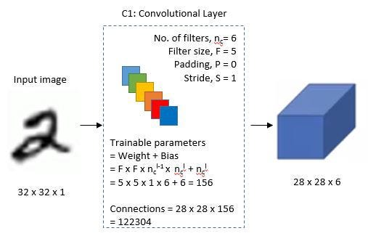
First Layer
Second Layer
Then, using a filter size of 22 and a stride of 2, the LeNet-5 adds an average pooling layer or sub-sampling layer. 14x14x6 will be the final image’s reduced size.
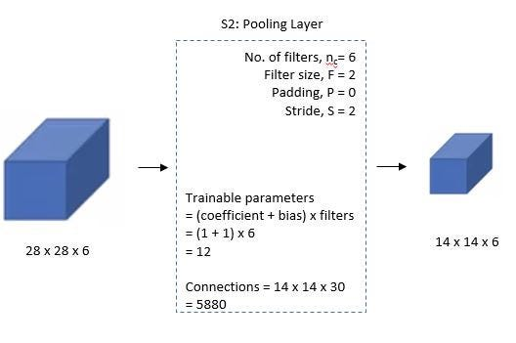
Second Layer
Third Layer
A second convolutional layer with 16 feature maps of size 55 and a stride of 1 is then present. Only 10 of the 16 feature maps in this layer are linked to the six feature maps in the layer below, as can be seen in the illustration below.
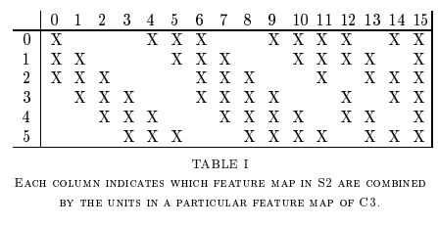
The primary goal is to disrupt the network’s symmetry while maintaining a manageable number of connections. Because of this, there are 1516 training parameters instead of 2400 in these layers, and similarly, there are 151600 connections instead of 240000.
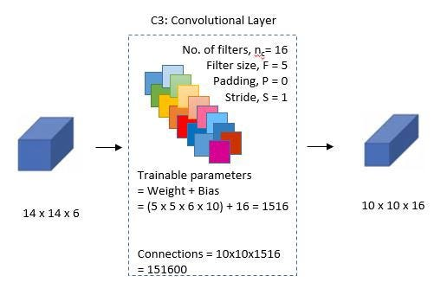
Third Layer
Fourth Layer
With a filter size of 22 and a stride of 2, the fourth layer (S4) is once more an average pooling layer. The output will be decreased to 5x5x16 because this layer is identical to the second layer (S2) but has 16 feature maps.
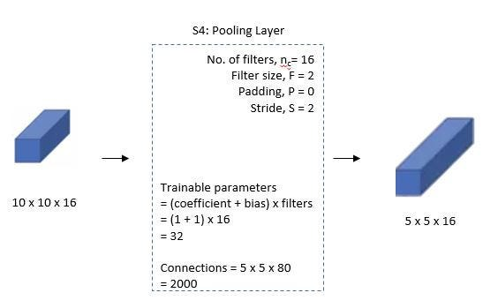
Fourth Layer
Fifth Layer
With 120 feature maps, each measuring 1 x 1, the fifth layer (C5) is a fully connected convolutional layer. All 400 nodes (5x5x16) in layer four, S4, are connected to each of the 120 units in C5’s 120 units.
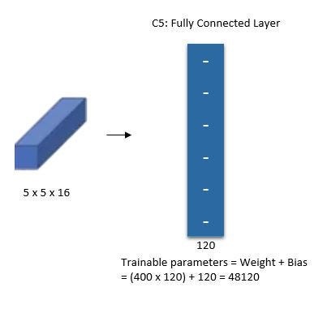
Fifth Layer
Sixth Layer
A fully connected layer (F6) with 84 units makes up the sixth layer.
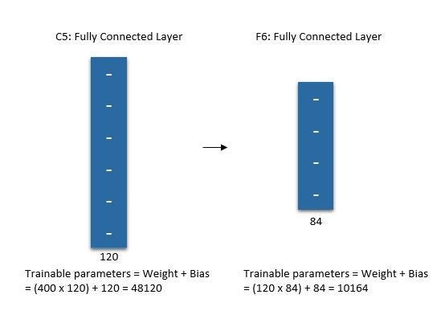
Sixth Layer
Output Layer
The SoftMax output layer, which has 10 potential values and corresponds to the digits 0 to 9, is the last layer.
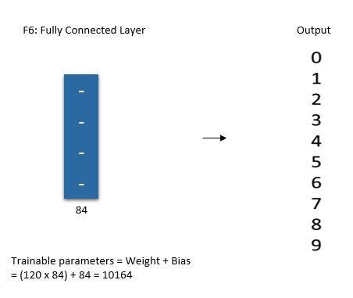
Output Layer
Summary of LeNet-5 Architecture
Press enter or click to view image in full size
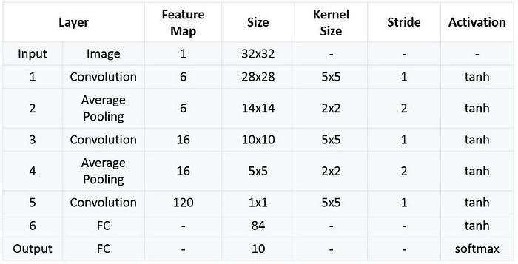
Summarized table for LeNet 5 Architecture
Implementation
We will be implementing the LeNet-5 Architecture on the MNIST Dataset because MNIST Dataset has images of 28x28 size which have characters are written that will help to show the better implementation of the architecture.
You can study more about the MNIST Dataset and can download the dataset from here — MNIST Dataset.
Although, MNIST Dataset is one of the practice datasets that are available in the TensorFlow library just for implementing and practising.
Download and Load the Dataset
Pre-processing and Normalizing the Data
Define LeNet-5 Model
Create a new instance of a model object using sequential model API. Then add layers to the neural network as per the LeNet-5 architecture discussed earlier. Finally, compile the model with the ‘categorical_crossentropy’ loss function and ‘SGD’ cost optimization algorithm. When compiling the model, add metrics=[‘accuracy’] as one of the parameters to calculate the accuracy of the model.
It is important to highlight that each image in the MNIST data set has a size of 28 X 28 pixels so we will use the same dimensions for LeNet-5 input instead of 32 X 32 pixels.
Evaluate the Model and Visualize the process
We can train the model by calling the model.fit function and pass in the training data, the expected output, the number of epochs, and batch size. Additionally, Keras provides a facility to evaluate the loss and accuracy at the end of each epoch. For this purpose, we can split the training data using the ‘validation_split’ argument or use another dataset using the ‘validation_data’ argument. We will use our training dataset to evaluate the loss and accuracy after every epoch.
We can test the model by calling model.evaluate and passing in the testing data set and the expected output.
We will visualize the training process by plotting the training accuracy and loss after each epoch.
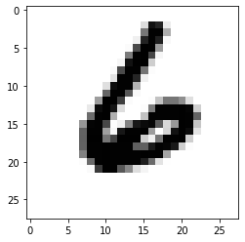
Output Visualization

Comparing CNN Vs ANN
https://www.analyticsvidhya.com/blog/2024/05/ann-vs-cnn-vs-rnn/

1. Architecture:
ANN (Artificial Neural Network):
Structure: ANNs are composed of layers of interconnected neurons: an input layer, one or more hidden layers, and an output layer.
Neurons: Each neuron is fully connected to every neuron in the previous and next layer.
Example Use Cases: Simple classification, regression problems, and general-purpose tasks such as predicting numerical outcomes, text classification, or binary classification tasks.
CNN (Convolutional Neural Network):
Structure: CNNs have a specialized architecture designed to handle structured grid-like data, such as images or time-series data. It consists of:
Convolutional layers: These apply filters (kernels) that slide across the input data (such as an image), creating feature maps. Convolutions help capture spatial features.
Pooling layers: Reduce the dimensionality of the data while preserving important features, improving efficiency and preventing overfitting.
Fully Connected layers: The final layers may be fully connected, similar to an ANN, to make predictions based on the features extracted by the convolutional layers.
Example Use Cases: CNNs excel at tasks where spatial hierarchies in data matter, such as image classification (e.g., recognizing objects in images), image segmentation, video processing, and even certain NLP tasks like text classification.
2. Input Type:
ANN: Works with structured data like tabular data, numeric or categorical values etc
CNN: Works with unstructured data where relationship between pixels is important like images, videos
3. Layer Types:
ANN: Consists mainly of fully connected (dense) layers.
CNN: Includes convolutional layers (which apply filters to extract features), pooling layers (to downsample the data), and sometimes dense layers at the end for classification or regression.
4. Feature Extraction:
ANN: Requires manual feature engineering or relies on hidden layers to capture important relationships between features. It’s not optimized for spatial relationships in data.
CNN: Automatically learns spatial hierarchies in the data (such as edges, textures, and shapes in images) through convolutional filters. The first layers of a CNN might detect simple features (like edges), while deeper layers capture more complex patterns (like shapes or objects).
5. Performance:
ANN: Can perform well on simpler, lower-dimensional data but struggles with high-dimensional data like images without preprocessing or feature extraction.
CNN: Specifically built for tasks like image processing, where spatial patterns matter. CNNs are state-of-the-art in tasks such as object detection, image classification, and image segmentation.
6. Example Use Case:
ANN: Predicting the price of a house based on features like square footage, number of bedrooms, etc.
CNN: Recognizing a dog in an image by detecting shapes and patterns in pixel values.

